**Student Name:** KARTHYAYENI P

**Registration No:** 22CSR089

**Course/Batch:** KONGU ENGINEERING COLLEGE (B.E COMPUTER SCIENCE AND ENGINEERING)

**CREATING MICROSERVICES FOR ACCOUNT AND LOAN**

**Introduction:**

This project focuses on developing two independent microservices—Account and Loan—using Spring Boot and Maven. Each service exposes a simple REST API without any backend connectivity, designed purely for learning purposes. By running on different ports, they demonstrate the core idea of microservice isolation and independent deployment.

**Objective:**

1. **To design and implement loosely coupled microservices** that function independently and can be deployed, maintained, and scaled separately.
2. **To expose RESTful APIs** for retrieving dummy account and loan details using Spring Boot and Spring Web modules.
3. **To configure multiple services to run on different ports**, ensuring they operate simultaneously without port conflicts, showcasing microservices behavior in a real-world scenario.

**Implementation Breakdown:**

**Account :**

**AccountApplication.java:**

package com.cognizant.account;  
import org.springframework.web.bind.annotation.*;  
import java.util.Map;  
@RestController  
@RequestMapping("/accounts")  
public class AccountController {  
  
 @GetMapping("/{number}")  
 public Map<String, Object> getAccountDetails(@PathVariable String number) {  
 return Map.*of*(  
 "number", number,  
 "type", "savings",  
 "balance", 234343  
 );  
 }  
}

**AccountController.java:**

package com.cognizant.account;  
  
import org.springframework.web.bind.annotation.*;  
  
import java.util.Map;  
  
@RestController  
@RequestMapping("/accounts")  
public class AccountController {  
  
 @GetMapping("/{number}")  
 public Map<String, Object> getAccountDetails(@PathVariable String number) {  
 return Map.*of*(  
 "number", number,  
 "type", "savings",  
 "balance", 234343  
 );  
 }  
}

**Loan:**

**LoanApplication.java:**

package com.cognizant.loan;  
  
import org.springframework.boot.SpringApplication;  
import org.springframework.boot.autoconfigure.SpringBootApplication;  
  
@SpringBootApplication  
public class LoanApplication {  
  
 public static void main(String[] args) {  
 SpringApplication.*run*(LoanApplication.class, args);  
 }  
  
}

**LoanController.java:**

package com.cognizant.loan;  
  
import org.springframework.web.bind.annotation.*;  
  
import java.util.Map;  
  
@RestController  
@RequestMapping("/loans")  
public class LoanController {  
  
 @GetMapping("/{number}")  
 public Map<String, Object> getLoanDetails(@PathVariable String number) {  
 return Map.*of*(  
 "number", number,  
 "type", "car",  
 "loan", 400000,  
 "emi", 3258,  
 "tenure", 18  
 );  
 }  
}

**Output:**

**Spring Initializer:**

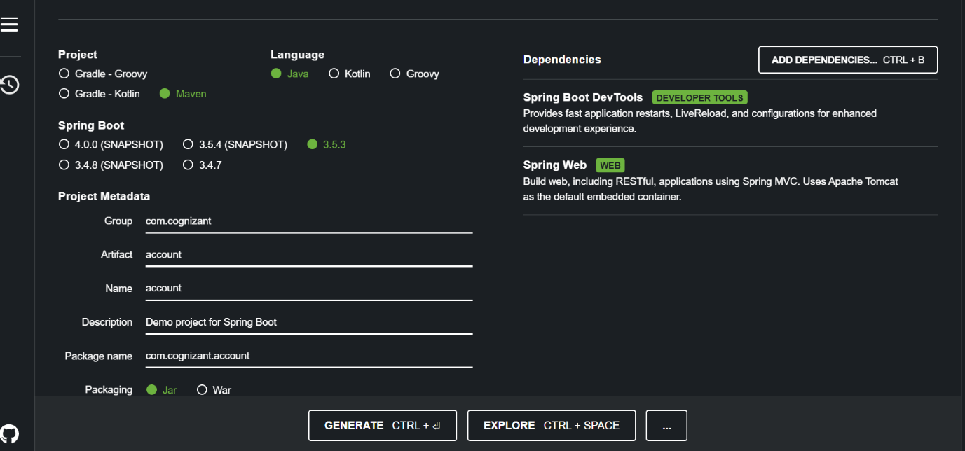

**Account:**

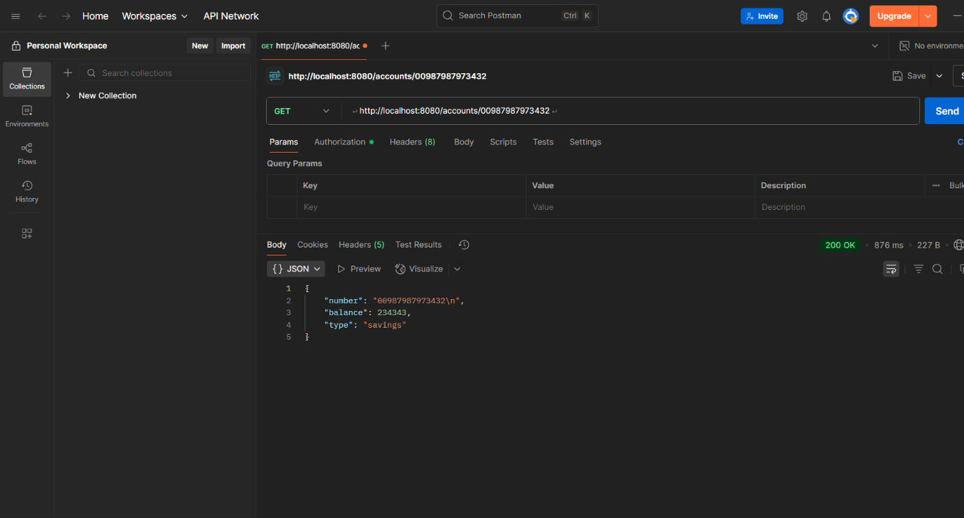

**Loan:**

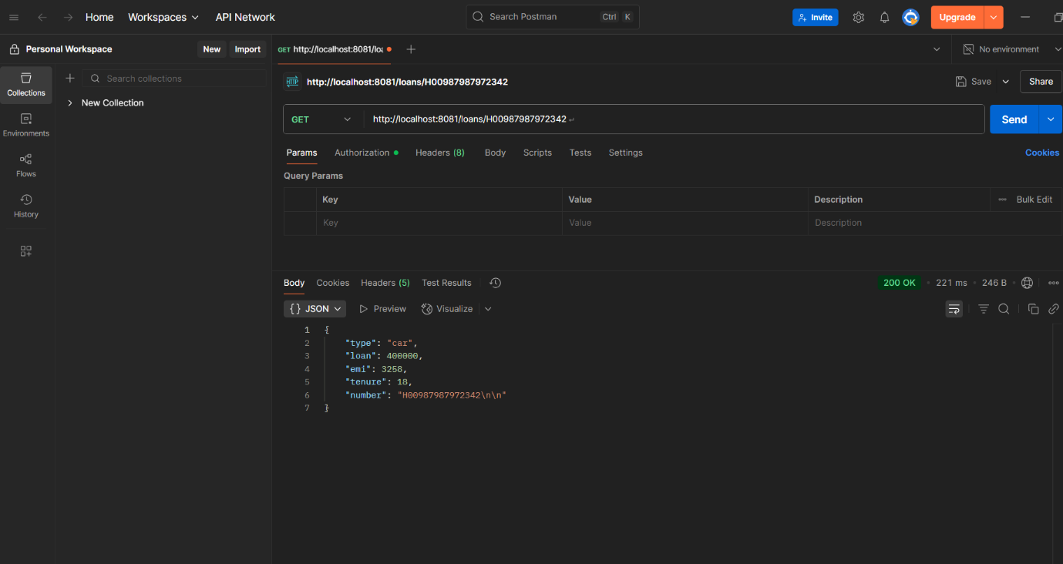

**Conclusion:**

The implementation of the Account and Loan microservices helped understand the basics of building and running RESTful services independently. It showcased how different services can operate on separate ports without interfering with each other. This project serves as a solid starting point for exploring more advanced microservices concepts.